API Response by Postman

- User Registration
- POST - {{host}}/user-register/

(Success Register) (Failed Register)
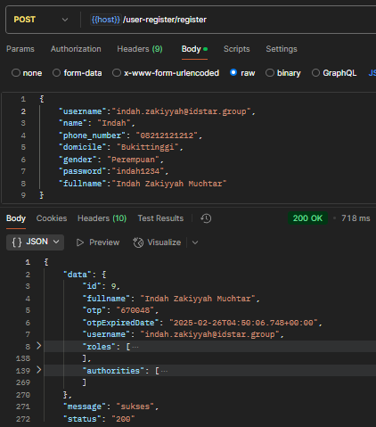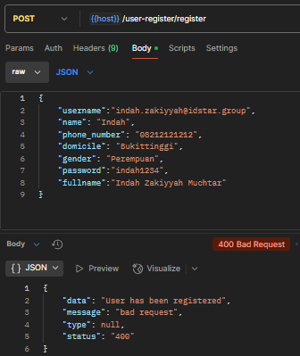

(Email Registration Otp) (Success Registration Page)
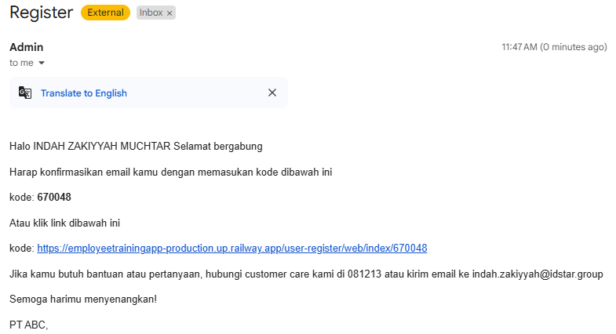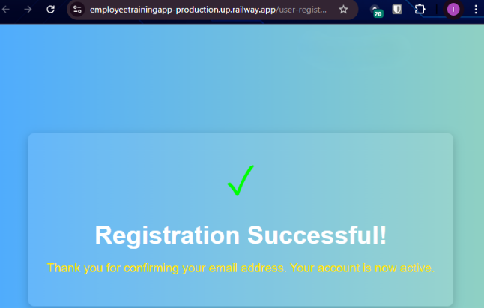

- POST - {host}}/user-register/send-otp
(Success Send Otp)
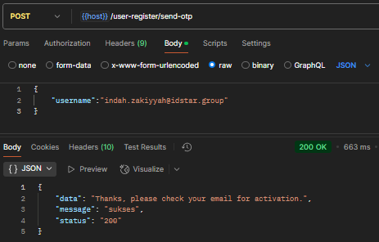
(Email for registration otp)
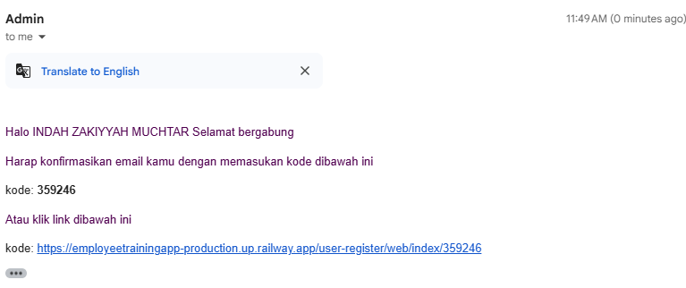

- GET - {{host}}/user-register/register-confirm-otp/{otp}
(Success confirm registration otp)
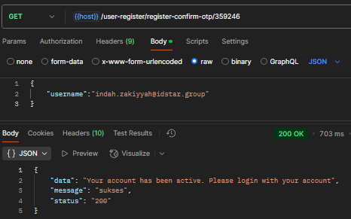

- Login
- POST - {{host}}/user-login/login
(Success Login)
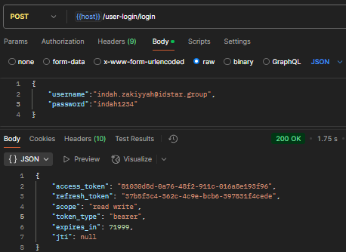
(Failed Login)
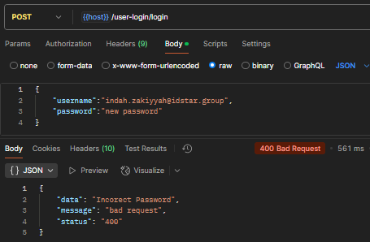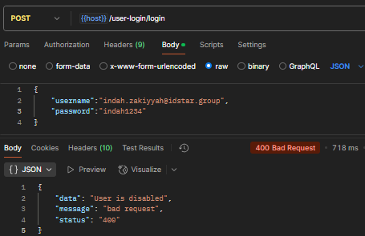

- Login with google
- POST - {{host}}/api/user-login/signin_google
(Success Sign in New User by Google)
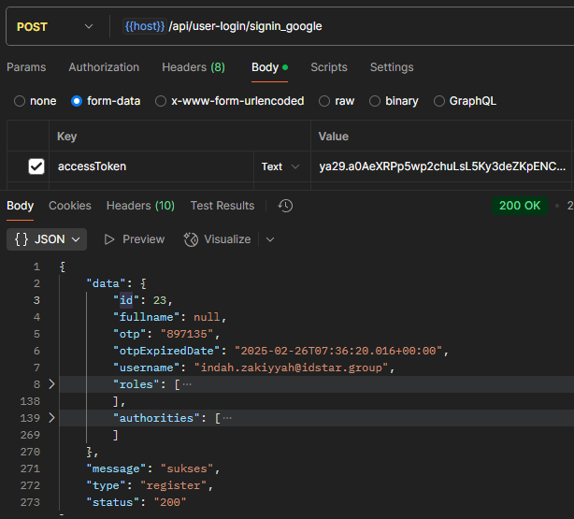

(Email Registration Otp) (Success Registration Page)
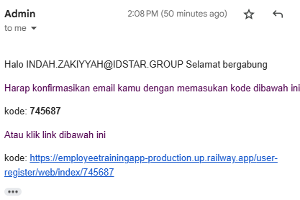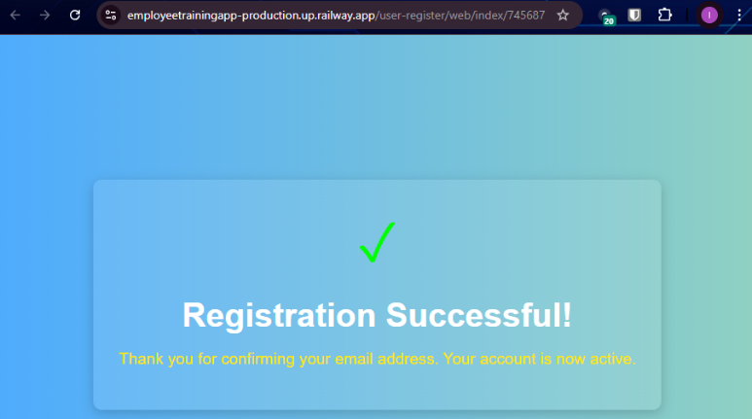

(Success Sign in Exist User by Google)
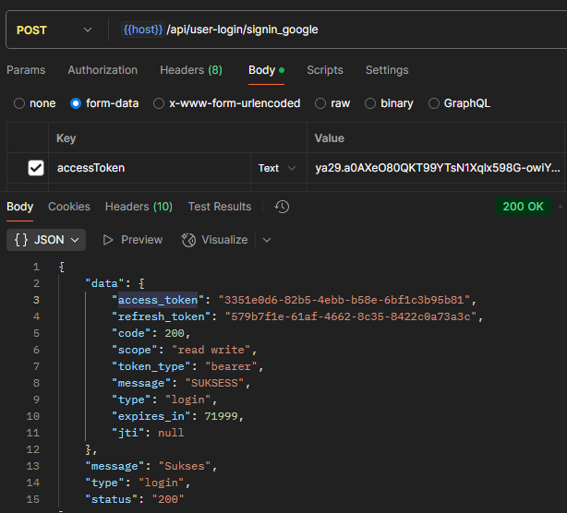

- Forget Password
- POST - {{host}}/forget-password/send

(Success Request Forget Password) (Email Forget Password Otp)
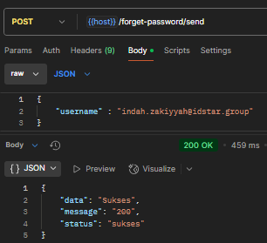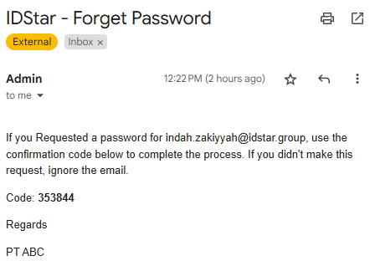
- POST - {{host}}/forget-password/validate

(Success Validate Forget Password)
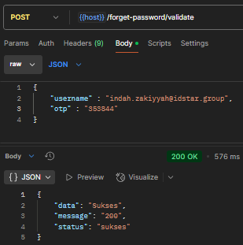
- POST - {{host}}/forget-password/change-password

(Success Change Password) (Failed Change Password)
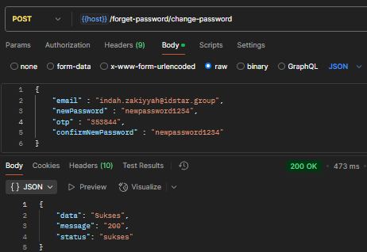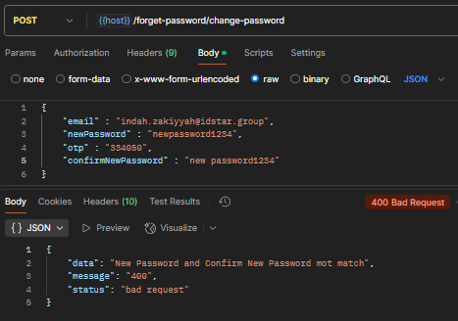

- File
- POST - {{host}}/v1/upload
(Success Upload File)
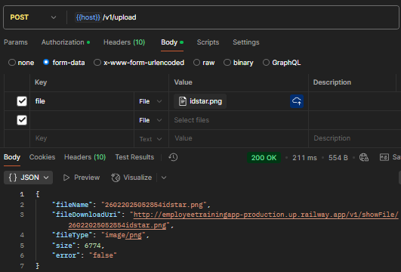
- GET - {{host}}/v1/showFile/{fileName}
(Success Show File)
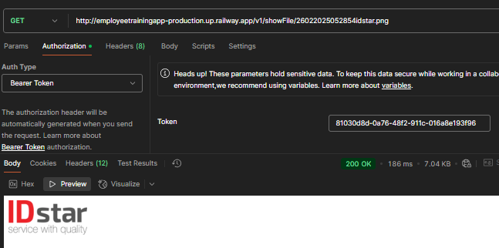

- Rest API Untuk Karyawan + Detail
- POST - {{host}}/v1/idstar/karyawan/save

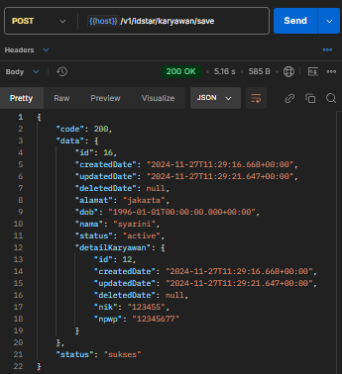

- PUT - {{host}}/v1/idstar/karyawan/update

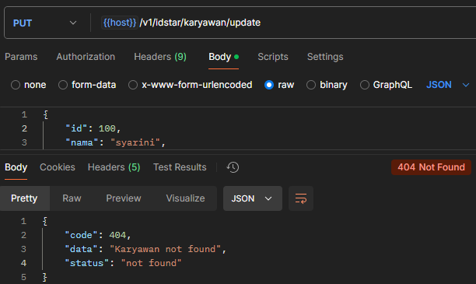
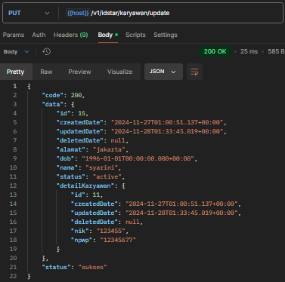

- GET LIST - {{host}}/v1/idstar/karyawan/list
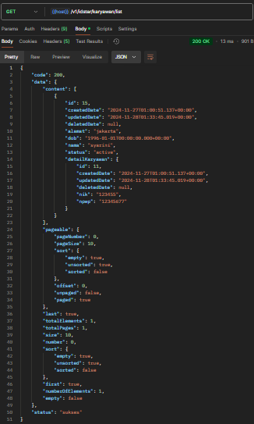

- GET ID - {{host}}/v1/idstar/karyawan/{id}

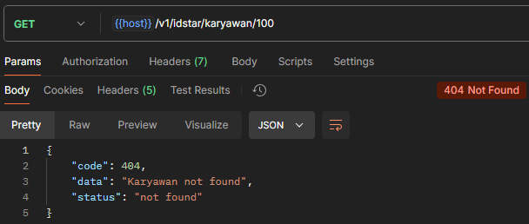
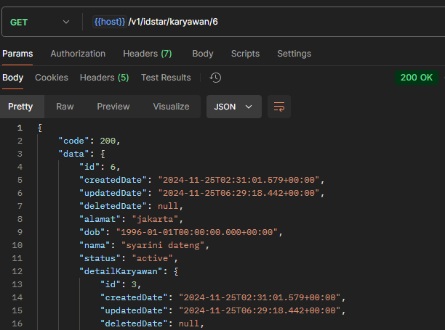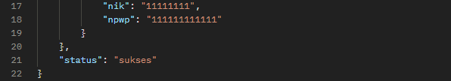

- DELETE - {{host}}/v1/idstar/karyawan/delete

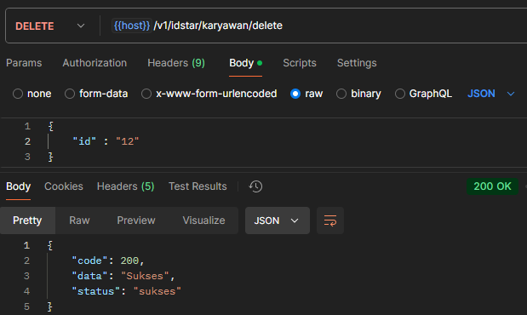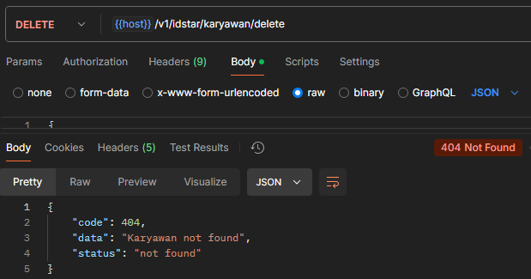

- Rest API Untuk Rekening
- POST - {{host}}/v1/idstar/rekening/save

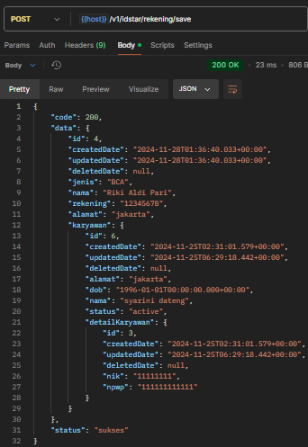

- PUT - {{host}}/v1/idstar/rekening/update

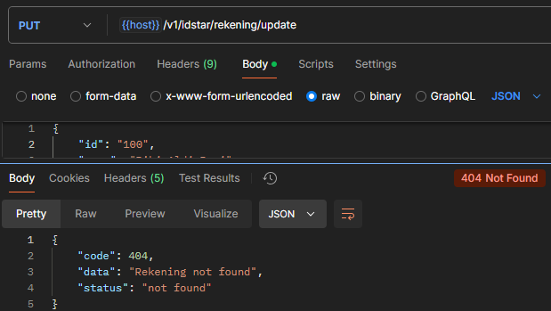
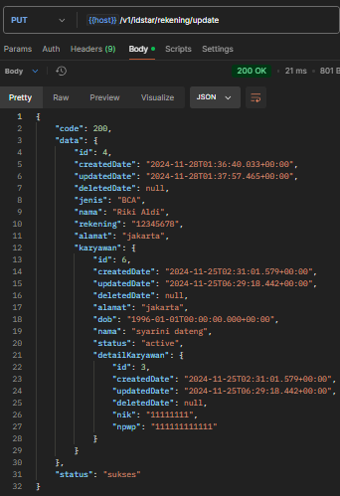

- GET ID - {{host}}/v1/idstar/rekening/{id}
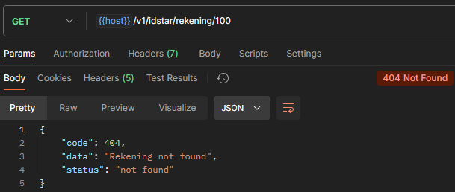
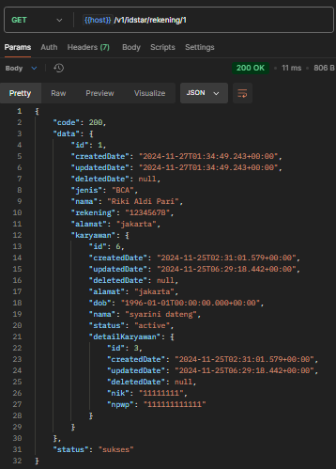

- GET List - {{host}}/v1/idstar/rekening/list

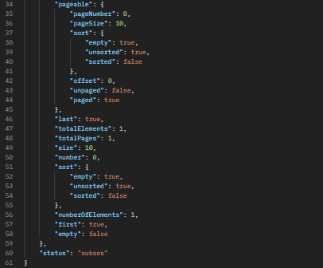
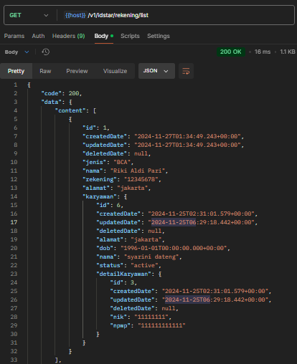

- DELETE - {{host}}/v1/idstar/rekening/delete

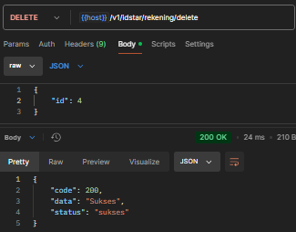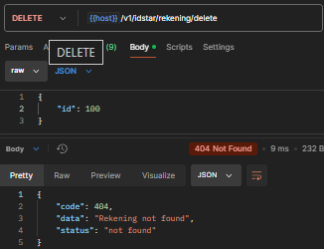

- Rest API Untuk Training
- POST - {{host}}/v1/idstar/training/save

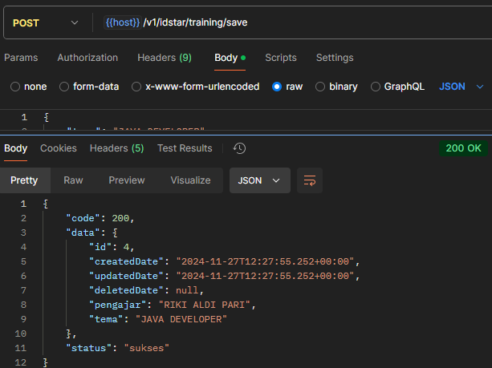

- PUT - {{host}}/v1/idstar/training/update

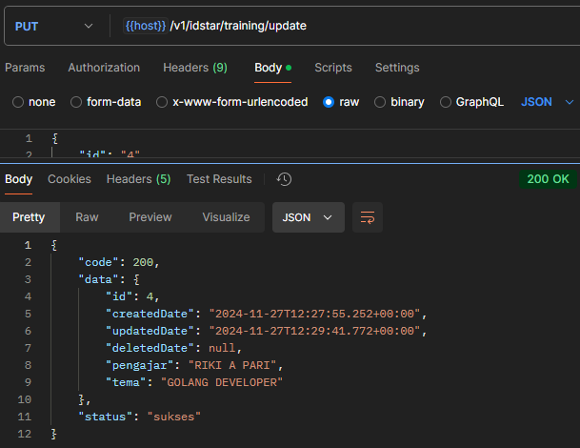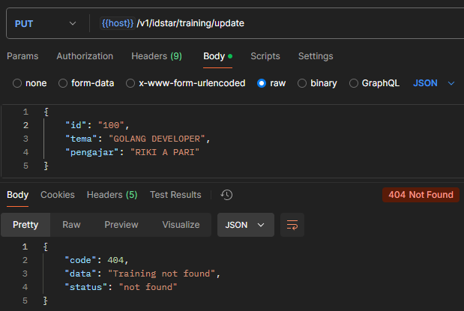

- GET LIST - {{host}}/v1/idstar/training/list

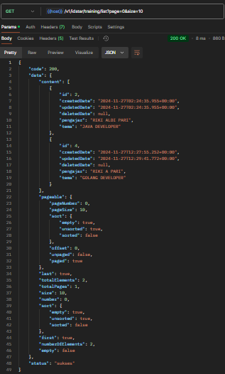

- GET ID - {{host}}/v1/idstar/training/{id}

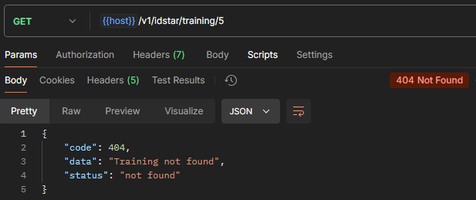
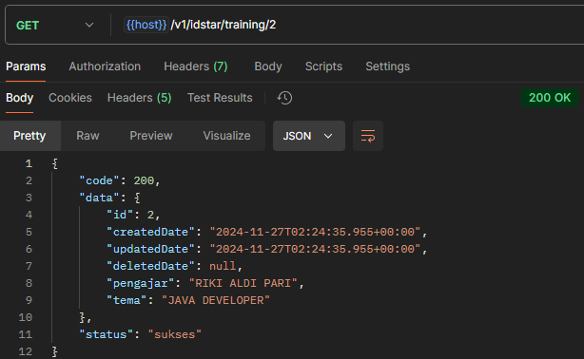

- DELETE - {{host}}/v1/idstar/training/delete

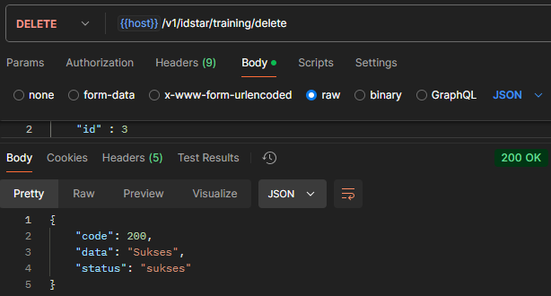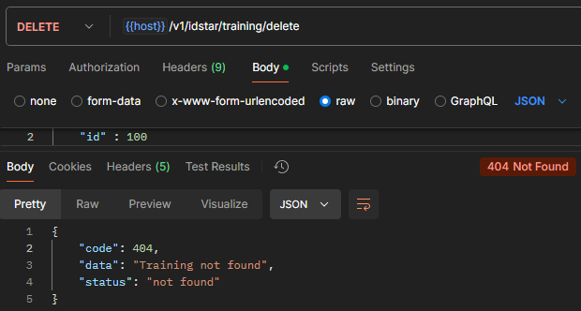

- Rest API Untuk KaryawanTraining
- POST - {{host}}/v1/idstar/karyawan-training/save

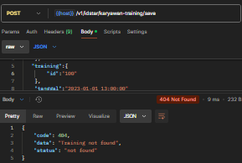
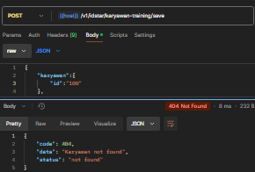
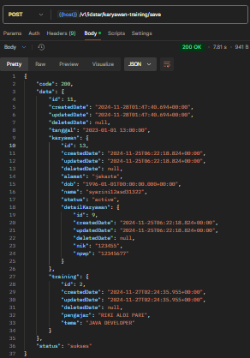

- PUT - {{host}}/v1/idstar/karyawan-training/update
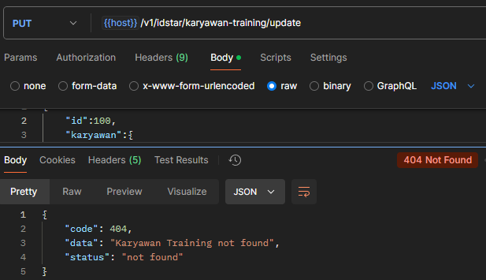
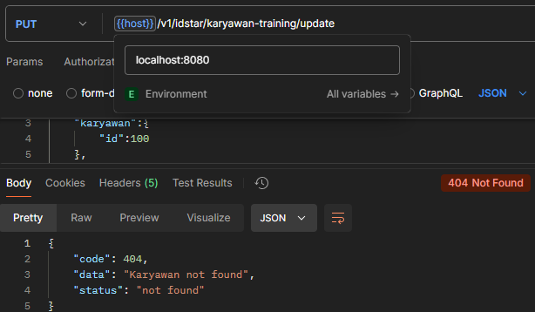
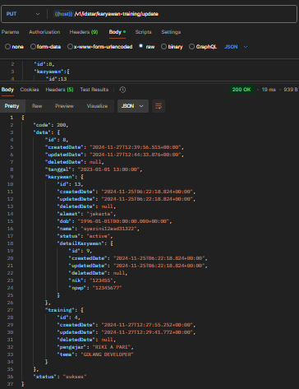
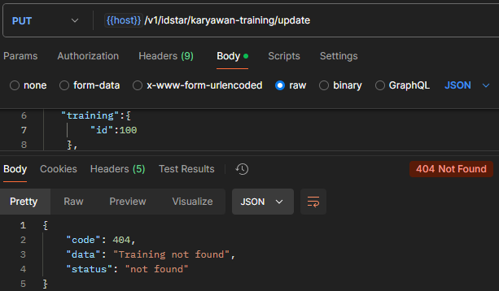

- GET LIST - {{host}}/v1/idstar/karyawan-training/list
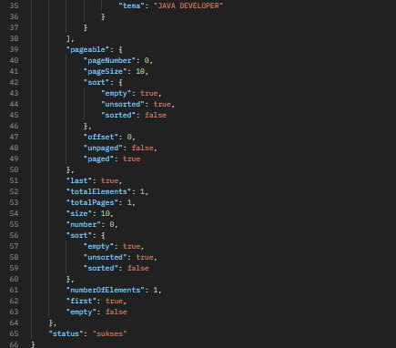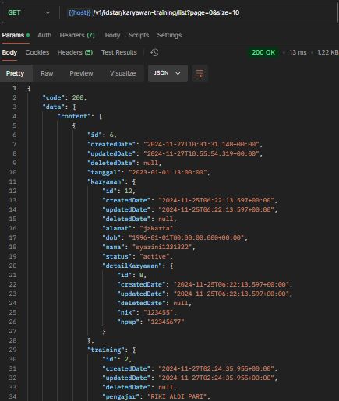

- GET ID - {{host}}/v1/idstar/karyawan-training/{id}

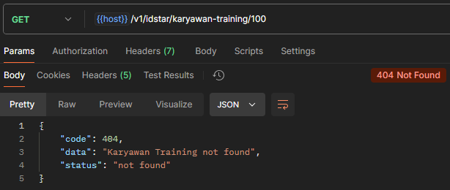
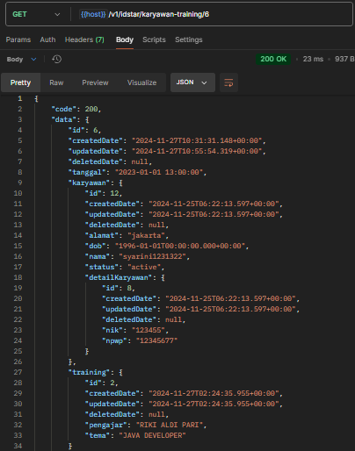

- DELETE {{host}}/v1/idstar/karyawan-training/delete

